ANA 610 Homework #2

Please refer to the assignment “grading rubric” for point allocation.
Please read the directions carefully.

Task #1 (68 pts):

In examining the 19,000+ row Donor datafile (s_pml_donor_hw_v3) and the associated data dictionary, you realize that there are no dates. Yet you know that you will be asked to generate reports based on the following dates:

- date when an individual was entered into the file (“ENTRY_DATE”),
- date of an individual’s first gift (“FIRST_GIFT_DATE”), and
- date of an individual’s last gift (“LAST_GIFT_DATE”).

Using SAS:

- Using the fields MONTHS_SINCE_ORIGIN, MONTHS_SINCE_FIRST_GIFT, and MONTHS_SINCE_LAST_GIFT and the SAS INTNX() function, create these date fields on the datafile, giving them a format of MM/DD/YYYY. Assume you are conducting this analysis on August 1, 1998.
  - What is the date of the most recent file entry?
04/01/1998
  - What is the date of the first gift?
01/01/1977
  - What is the date of the last gift?
05/01/1998
  - What is the median length of time (in months) between the first and last gift?
48
- Using PROC UNIVARIATE with default settings,
  - Show the histograms for ENTRY_DATE and FIRST_GIFT_DATE with the year displayed on the x-axis.
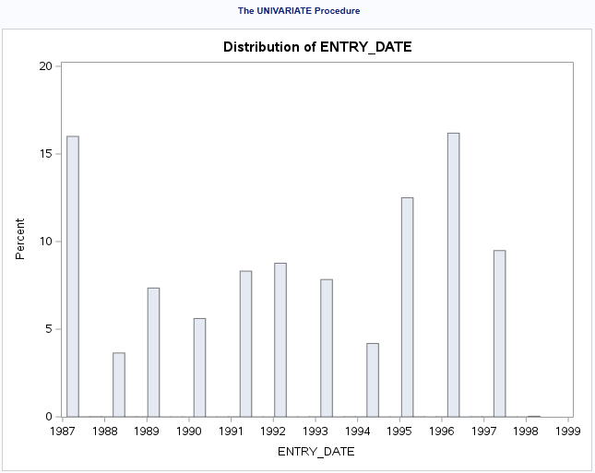
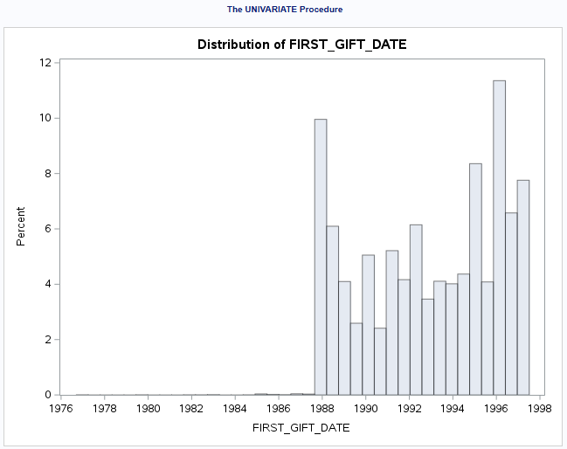

  - Based on these two histograms, what is odd about ENTRY_DATE and FIRST_GIFT_DATE (i.e., considering the definitions of these two dates, is there a data integrity issue we need to address)? Explain.
One could pretty much suspect that the entry and first gift dates could be the same or close to each other. There are some first gift dates that proceeded recorded entry dates in the file. These could be errors, and should be verified with the client. Given the extremely high level of correlation between ENTRY_DATE and FIRST_GIFT_DATE data, imputation could be performed to replace the suspect FIRST_GIFT_DATE data with its corresponding ENTRY_DATE data. In addition, when an eventual model is generated from the data, only one of these variables would probably be necessary.

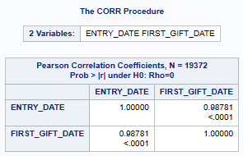

- Using the SAS YEAR() function, create 3 new fields, showing the YEAR (in YYYY format): ENTRY_DATE_YEAR, FIRST_GIFT_DATE_YEAR, and LAST_GIFT_DATE_YEAR.
  - How many individuals were added to the file in 1998? Support your answer by showing an SAS output table.
7
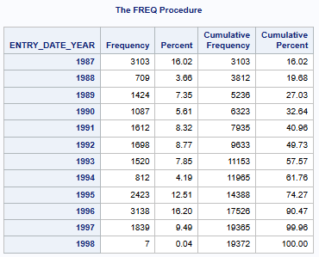

  - Which year had the lowest mean LAST_GIFT_AMT? Support your answer by showing an SAS output table using LAST_GIFT_DATE_YEAR .
1997
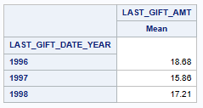

  - In CLUSTER_CODE = 9 and LAST_GIFT_DATE_YEAR = 1997, what was the mean LAST_GIFT_AMT? Support your answer by showing an SAS output table again using LAST_GIFT_DATE_YEAR .
15.26
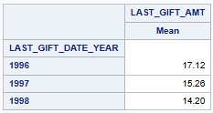

Using R:

- Show here
  - R code for how you would create the same 3 date variables ENTRY_DATE, FIRST_GIFT_DATE and LAST_GIFT_DATE.
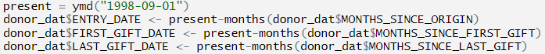

  - R-generated output from summary.Date() showing the min, median, mean and max values for each of these 3 date variables.
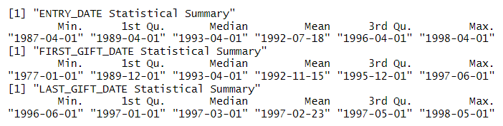

- Show here
  - R code for how you would create the variable LAST_GIFT_DATE_YEAR.

  - R-generated output showing the mean LAST_GIFT_AMT by LAST_GIFT_YEAR (these means should match what you found above in 3(b)).
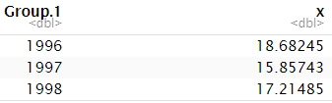

Task #2 (133 pts):

- The AnyState Veterans of Foreign Wars solicits donations from adults aged 18+ years. DONOR_AGE may be an important variable in explaining whether an individual donated and, if so, how much they donated.
  - Using a table to summarize your findings, perform a quick data integrity check (using R or SAS) on DONOR_AGE and identify issues which may exist with respect to this variable. Check and report briefly (including a brief note per item if there is any concern) on missing values, odd values, extreme values on the low and high end, distribution skewness, value consistency and anything else you think is important.
Note: There are 4,795 missing values for DONOR_AGE in the dataset (32.9%). There are 206 values that are under the age of 18 (1.4%).
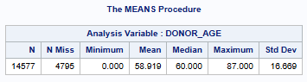
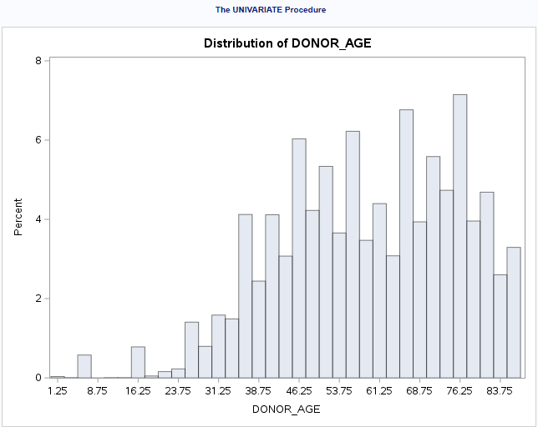
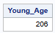

  - One integrity issue you just uncovered is missing values. Should these records (rows) with missing values for DONOR_AGE be removed from the modeling datafile? Explain fully why, or why not?
Given this is a fairly large number of records (4,795), the client may not want to remove the records. The originally defined target variable data for TARGET_B and TARGET_D, along with other potentially important explanatory variables could be affected by the removal of records. At this point, there is uncertainty as to what effect DONOR_AGE may have on the estimation of the target variables, but it definitely seems like a reasonable profile answer to consider. Recommend the exploration of imputation options for the missing values.

- Using SAS, impute the missing values of DONOR_AGE using mean unconditional and the conditional approaches hot-deck, stochastic regression, and predictive mean matching (PMM). Your analysis will make use of the following:

- Upon guidance from AnyState, the modeling datafile should be limited to those records with either missing values for DONOR_AGE or values for DONOR_AGE >= 18.

- The control variables for the conditional approaches are months_since_origin, in_house, pep_star, lifetime_card_prom, lifetime_prom, and months_since_first_gift.

- Months_since_origin will be used for the correlation metric.

  - Report the findings of your imputations in the following table (report out to 3 decimal places; right justify numeric cell entries):

 |  | Imputed Values
Statistic | Observed Values | Mean | Hot-Deck | Stochastic Regression | PMM | kNN
Seed value => |  |  | 12345 | 12345 | 12345 | 12345
N | 14,371 | 19,166 | 19,166 | 19,166 | 19,166 | 19,166
Min | 18.000 | 18.000 | 18.000 | -9.712 | 18.000 | 18.000
Mean | 59.587 | 59.587 | 59.602 | 59.273 | 59.339 | 59.130
Median | 60.000 | 59.587 | 60.000 | 59.347 | 60.000 | 59.000
Max | 87.000 | 87.000 | 87.000 | 108.536 | 87.000 | 87.000
STD | 15.808 | 13.688 | 15.810 | 15.821 | 15.853 | 15.915
Correlation | 0.276 | 0.238 | 0.210 | 0.281 | 0.278 | 0.299

  - For each imputation, show here the “overlaid histogram” produced by PROC SGPLOT (imputed variable vs. observed variable) and the “overlaid boxplot”. Make sure that the variable labels used by SGPLOT clearly differentiate between the observed and imputed variables. Use binwidth = 5 (histogram) and transparency = .5 (histogram and boxplot).

Unconditional Mean Imputation Histogram Overlay:

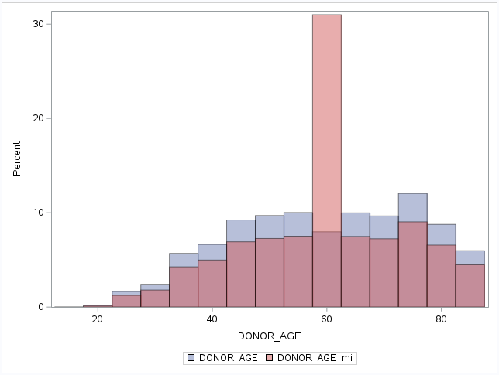
Unconditional Mean Imputation Boxplot Overlay:

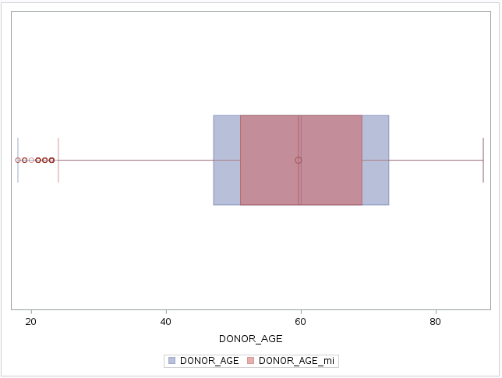

Conditional Hot-Deck Imputation Histogram Overlay:

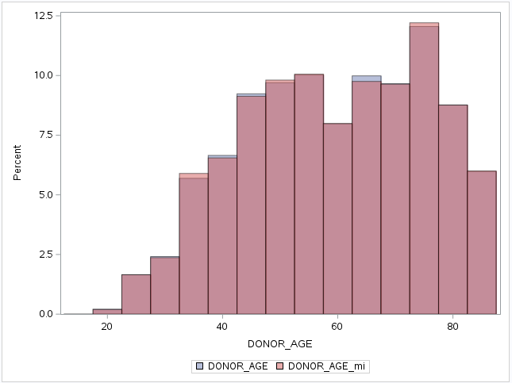

Conditional Hot-Deck Imputation Boxplot Overlay:

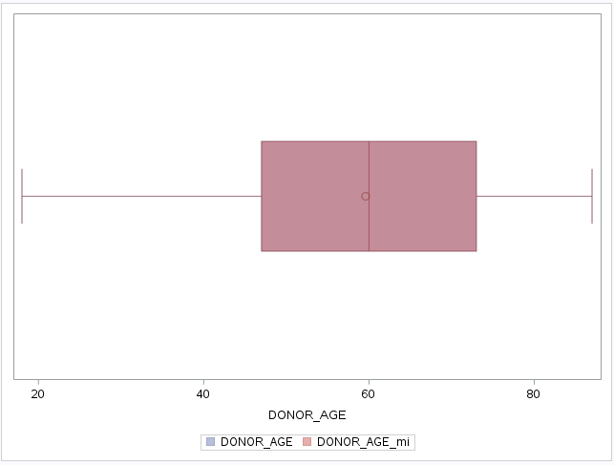

Conditional Stochastic Regression Imputation Histogram Overlay:

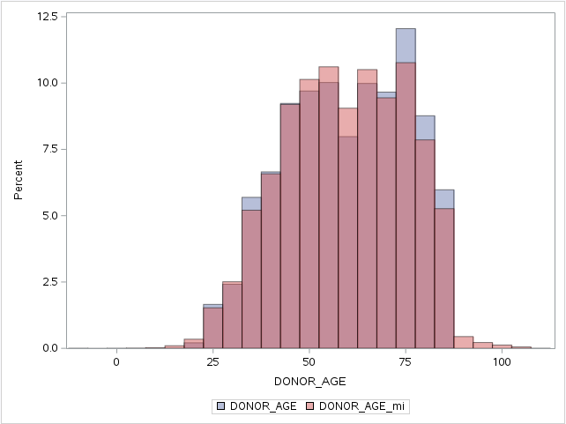

Conditional Stochastic Regression Imputation Boxplot Overlay:

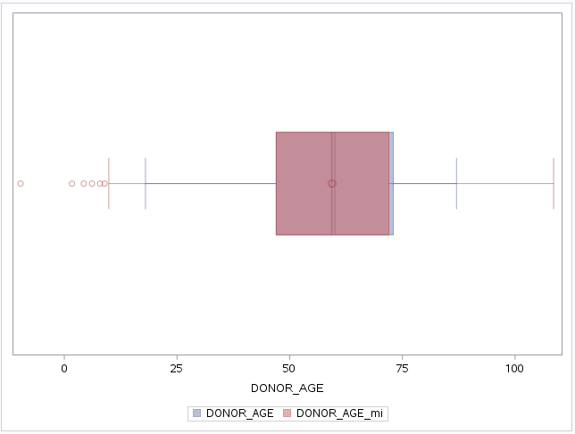

Conditional Predictive Mean Matching (PMM) Imputation Histogram Overlay:

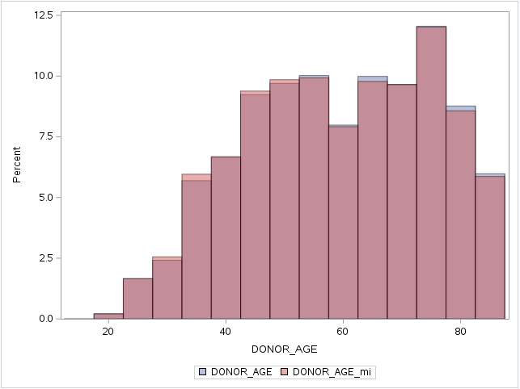

Conditional Predictive Mean Matching (PMM) Imputation Boxplot Overlay:

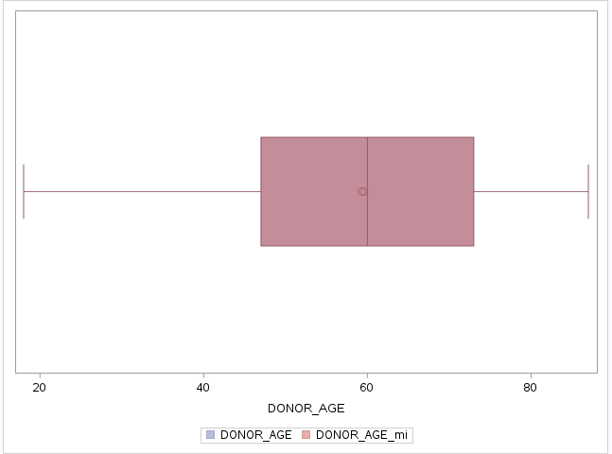

  - Based on the 4 imputations, which one do you recommend be used? Explain fully.
Of the four methods evaluated, Hot-Deck would be chosen, due to having the closest numbers to the mean and standard deviation for the observed values, as well as having notably matching histogram and boxplot overlays to the observed values. The only potential drawback was Hot-Deck’s correlation with MONTHS_SINCE_ORIGIN, which all of the other methods were closer to the observed values. A correlation value of 0.276 is on the weaker side, and imagine DONOR_AGE would probably have a stronger correlation to other variables in the dataset. Performing correlation to a numeric outcome variable like Target_D or different numeric explanatory variables better representing the variable population would seem logical.
If MONTHS_SINCE_ORIGIN seemed like a potential outcome variable, I might consider
using PMM instead, with it having a similar correlation value, a reasonably close standard deviation, and notably matching histogram and boxplot overlays to the observed values.

  - What should you always do when you impute missing values regardless of the technique? Explain fully.
The first step would be to create a missing value indicator and duplicate of the variable to impute. The second step would be to check how many missing values there are in the observed values. The third step would be to examine the distribution of the variable’s observed series. The fourth step would be to impute missing values and output imputed data. The fifth step would be to conduct comparative analysis between the observed data and the imputed data.

- Imputing missing values for categorical variables, such as WEALTH_RATING, is not necessarily as straight forward as for continuous variables.
  - Using a table, perform a quick data integrity check (using R or SAS) on WEALTH_RATING and identify all issues which may exist with respect to this variable. Check and report briefly (including a brief note per item if there is any concern) on missing values, odd values, extreme values on the low and high end, distribution skewness, value consistency and anything else you think is important.
*Note: There are 8,810 missing values for WEALTH_RATING in the dataset (45.5%). Ratings are from 0-9, but unsure exactly how they derived. Need to verify with client. There is a steady frequency increase throughout the range of WEALTH_RATING values in the dataset.
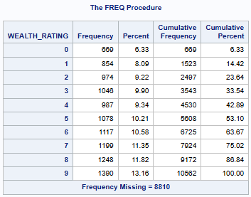
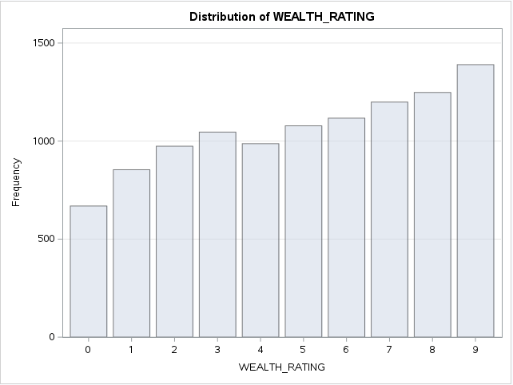
  - Using SAS, impute the missing values of WEALTH_RATING using the mode unconditional and PMM conditional approaches.

- The modeling datafile should include ALL 19,372 records (rows).

- The control variables for the PMM conditional approach are median_home_value, pep_star, and per_capita_income.

- Per_capita_income will be used for the correlation metric.

NOTE – WEALTH_RATING is already machine numeric. So, you do NOT need to create a numeric version as shown in the lecture slides and can proceed directly to the mode calculation and imputation stages.

    - Report the findings of your imputations in the following table (report out to 3 decimal places, right justify numeric cell entries):

 |  | Imputed Values
Statistic | Observed Values | Mode | PMM
Seed value => |  |  | 12345
N | 10,562 | 19,372 | 19,372
Min | 0.000 | 0.000 | -7.696E-17
Mean | 5.005 | 6.822 | 5.068
Median | 5.000 | 9.000 | 5.000
Mode | 9.000 | 9.000 | 9.000
Max | 9.000 | 9.000 | 9.000
STD | 2.815 | 2.877 | 2.805
Correlation | 0.521 | 0.270 | 0.505

    - For each imputation, show here the “overlaid histogram” and “overlaid boxplot” produced by PROC SGPLOT (imputed variable vs. observed variable). Make sure that the variable labels used by SGPLOT clearly differentiate between the observed and imputed variables. Use binwidth = 1 (histogram) and transparency = .5 (histogram and boxplot).

Unconditional Mode Categorical Imputation Histogram Overlay:

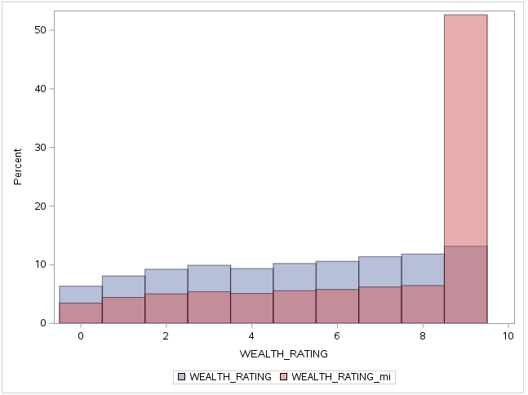

Unconditional Mode Categorical Imputation Boxplot Overlay:

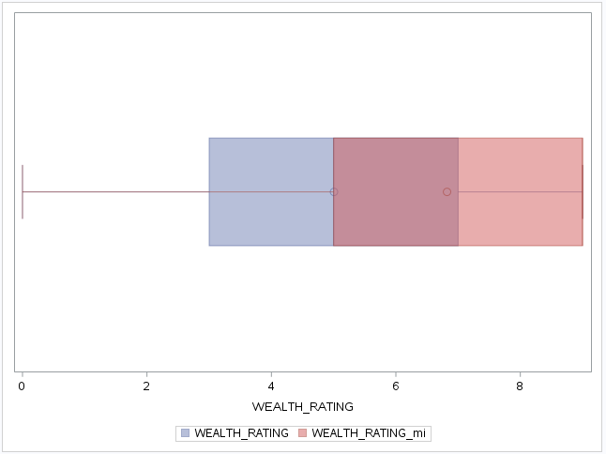

Conditional Predictive Mean Matching (PMM) Categorical Imputation Histogram Overlay:

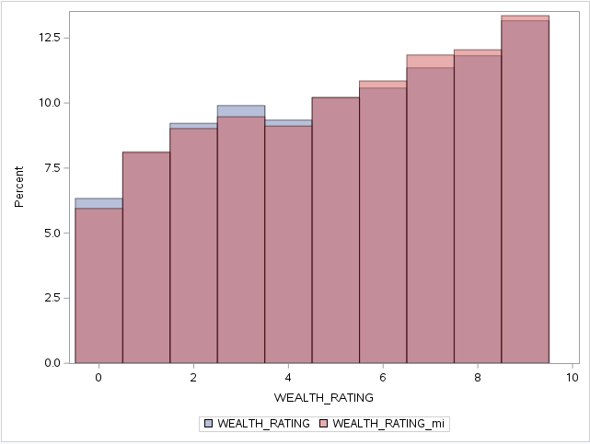

Conditional Predictive Mean Matching (PMM) Categorical Imputation Boxplot Overlay:

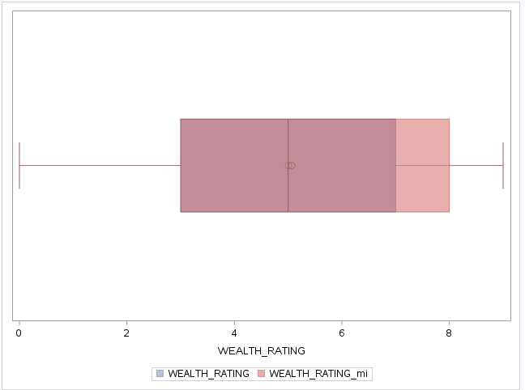

  - Based on the 2 imputations, which one do you recommend be used? Explain fully.
The predictive mean matching (PMM) imputation is clearly superior to unconditional mode imputation in this application, and probably most applications. The distribution of missing value imputations made sense, and did not just lump them all into one mode value. This was clearly represented in the histogram overlay. There were 483 observations allocated to a category slightly below zero in the frequency diagram, but those values would appropriately sit with the 0 category. There is probably
a parameter setting to keep that from happening. Nice to see the use of numerical statistics and correlation in this process. Much of this was taboo for categorical variables with our ANA600/605 professor.

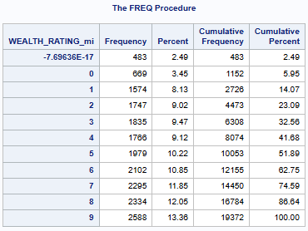

Task #3 (19 pts)

Variables with extreme or non-normal distributions make hypothesis testing difficult and can adversely affect model fit, depending on the algorithm employed.

- Is the distribution of the variable LIFETIME_GIFT_AMOUNT “extreme”? Explain fully. Upon what statistic are you basing your analysis? Use the entire 19,372 row datafile.
The distribution of the LIFETIME_GIFT_AMOUNT variable is heavily skewed to the right (Skew=6.594). Some effort to verify some of the extreme values with the client could be made, but there is no obvious reason to believe that the data is not accurate. Given that the skew clearly exceeds the standard of 5, it is possible that a transformation could be used to generate a more normal distribution for eventual use of the variable with a predictive model.

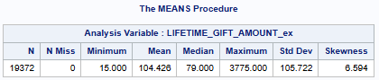
- If it is extreme, manually using Tukey’s Ladder of Powers, identify the single transformation which yields the most normal distribution. Show the before and after histogram from PROC UNIVARIATE as well as the before and after skewness statistic.

Before:
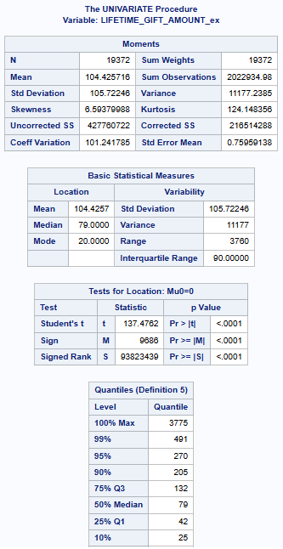
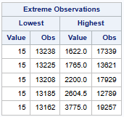

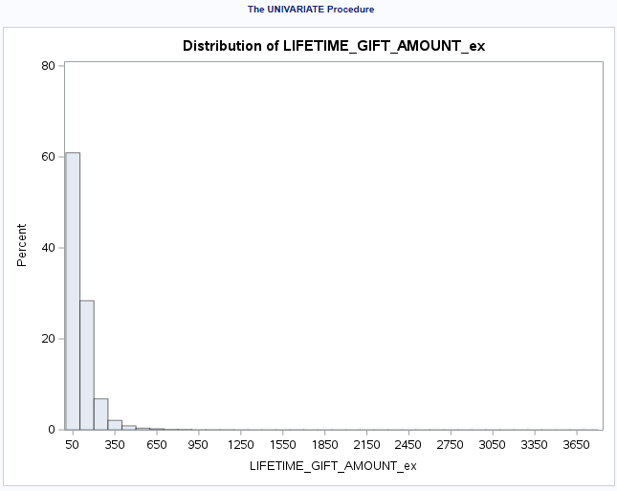

The Tukey logarithmic transformation yielded the best skew result (0.041).

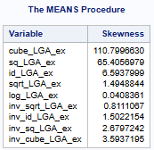

After:
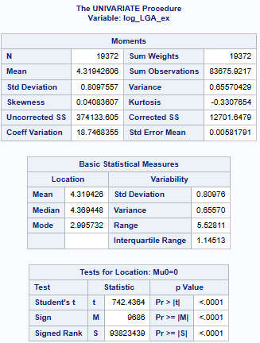
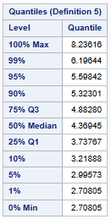
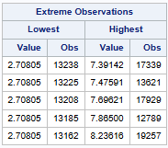

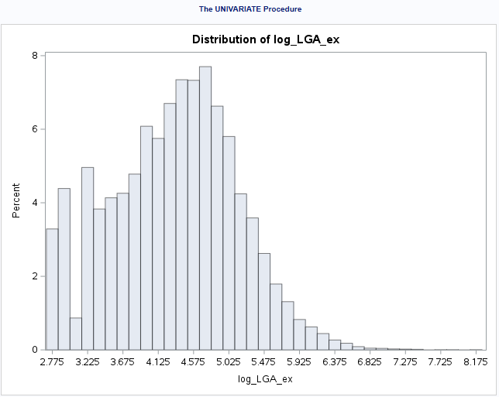

- Using a BoxCox transformation, can the skewness be further reduced? Explain fully, including in your answer:
- The optimal lambda and the new skewness value.
- Output chart produced by PROC TRANSREG.
The optimal lambda (0) and skew produced by the BoxCox transformation (0.069) does not improve upon what was obtained through the Tukey log transformation (0.041). The histogram distributions are very similar. The t-statistic and variability parameters were slightly better with the BoxCox transformation. Believe one could test each of these transformations in a prospective model to see which performs better.

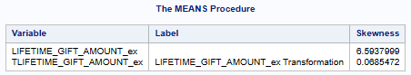
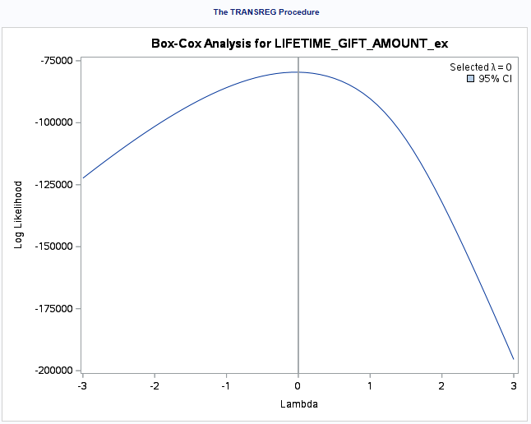
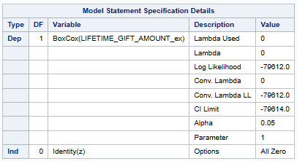

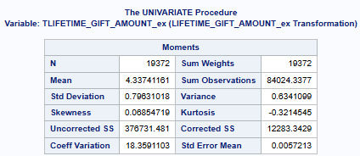

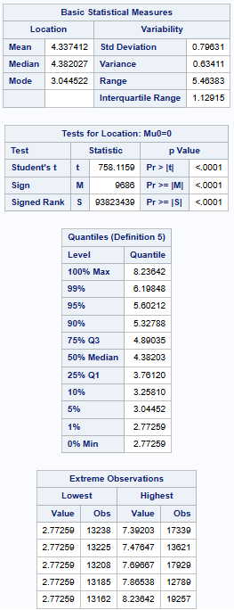
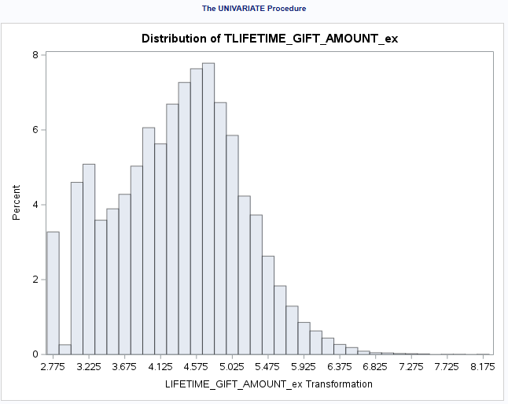

Extra Credit (20 pts)

- Using R,
  - Show here your R code for how you would use K-nearest neighbor (kNN) to impute the missing values of DONOR_AGE using kNN() from the VIM package. Use the same subsample requirements used in Task #2.
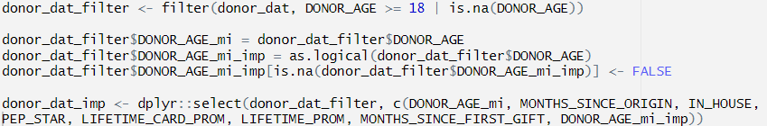

  - Add a column to the table you filled in in Task #2 which reports the stats obtained from using kNN. Done.

  - Do these new findings change your recommendation as to which imputation method to use? Explain fully.
Could not get kNN() to work with any k value greater than 1, but provided the required values for 1b. Based upon these findings, I would not change my imputation method recommendation for use. The mean, median, and standard deviation were much further from the observed values than the other imputation options. Suspect if I could have been able to use a higher k value that it could have been more competitive. See the error below.

- Using SAS’s PROC UNIVARIATE, the ENTRY_DATE variable you created in TASK #1, and the output table “Basic Statistical Measures”:
- By hand, using 365.25 to convert days into years, calculate the year of the median entry date out to two decimal places (i.e., XXXX.XX). Support your answer by showing the Basic Statistical Measures output table.
- Using SAS, calculate and show SAS output the same median entry date ENTRY_DT_MEDIAN, but in MM/DD/YYYY format, using the INTNX() function and a new variable MEDIAN_DAYS set equal to the median value shown in the Basic Statistical Measures output table. Also show your code.
- Explain fully whether the values in (a) and (b) are consistent with each other.

Homework deliverables:

- Tasks 1 – 3 plus extra credit:
  - separate Word doc with your analysis and discussion, including all tables and charts.
  - SAS program (as a .sas file) with all code used for Tasks 1 – 3 plus extra credit.

Refer to pre-recorded session #4 SAS code (Working with Dates) for examples.
See footnote 1

